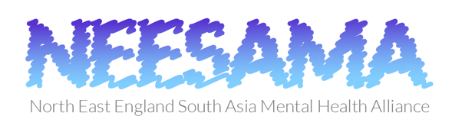

Child psychodynamic psychotherapy application form

Please complete all sections of form electronically and adhere to word limits - additional text will not be considered.

Applicants must be either Child & Adolescent Psychiatrists or Psychologists. They can be trainees in their respective fields or have finished training within the past 3 years.

By submitting this application, you agree, if successful, to write an article (up to 500 words) reflecting on your experience of attending the course, how it will benefit you and your host institution which will be submitted to the Mental Health Foundation NE Branch.

Send completed forms by 9 am (UK time) on Monday 17 August 2020 to Mrs Kathryn Parker (Kathryn.Parker@cntw.nhs.uk).

- Name:________________________________________

- List all qualifications in table below

Qualification | Awarding institution | Date awarded

- How would attending the child psychodynamic psychotherapy course help you? (maximum 250 words)

- How would your attendance at the course benefit your institution? (maximum 250 words)

